HAPPY HOLIDAYS!

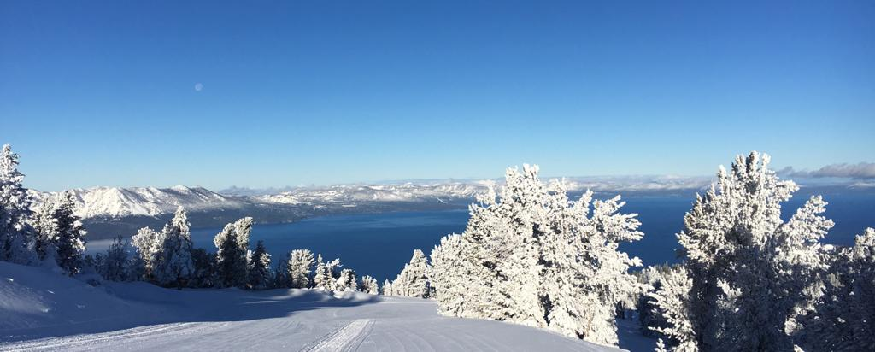

THE HOLIDAYS:

We are at the start of the 2023/24 holiday season with Christmas day this Monday and New Year’s day the Monday after. We anticipate being busy from now through Sunday, January 7th.

We are definitely seeing an increase in the number of guests we have reserved for the next couple of weeks. However, as a result of the lack of snow we are not as busy as this time last year.

We are going to focus scheduling on full time staff over the holiday period. We may still ask you to come in as a part time instructor but there may be less work for part timers than this time last year. If you are requested as a part time coach you are more than welcome to come in and teach the lesson.

There is plenty of availability at this time if anyone wants to book a private lesson.

We are operating Ski and Ride School out of California and the Gondola (wind permitting) and will be opening up on blue terrain starting this Monday. We have already made the call not to open Boulder prior to Tuesday, 1/2/24 at the earliest.

Today saw the opening of Mombo in California as well as Comet and Upper Big Dipper in Nevada.

We will see some other areas open up soon that are not groomed e.g. Ridge bowl and Jack’s.

Snow is being made overnight at Cal. base with the goal of opening the Forest as soon as possible.

Snowmaking up on the mountain is focused on expanding terrain as soon as possible.

Please, keep thinking snow (or at least cold, so we can make snow).

CONTINUOUS LISTENING EMPLOYEE SURVEY: Thank you to everyone who took a few minutes to take part in the recent Continuous Listening Employee Survey.  The results and especially your comments are incredibly valuable for our school and our resort.  I promise that decisions have been made - and will continue to be made - based on your feedback.  We’ll have another one in February.  Thank you for the help!

RECOGNITION & GUEST COMMENTS: We would like to take a moment to **ACKNOWLEDGE** and **CONGRATULATE** the following employees for successfully obtaining their **LEVEL 1 CERTIFICATION.**

ALEX JORDAN

CHASE BOMAR

SHAWN WEN

Remember, instructors who successfully complete and are awarded one of the certifications/accreditations are eligible for reimbursement of exam fees and minimum pre-requisites for all portions of the successful exam.

We appreciate the hard work and dedication of **all our staff**. We want to recognize those individuals that gave our guests an “EXPERIENCE OF A LIFETIME”.

Some comments shared by guests:

* “My coach **Greg** is the best. Super knowledgeable and friendly!”
* **“Danny** (instructor from Britain) and **Julz** (instructor from Siberia Russia) stand out in my mind as going above and beyond.  Your instructors would be the reason I come back.  They made my experience! Thanks!”
* Coach **Bob** is awesome!
* My Ski instructors were so kind! **Josefina** and the other guide were fantastic!!!!

TRAVELING PRIVATE LESSONS: If your private lesson guest would like to travel to Northstar or Kirkwood this holiday please let us know.

We need to know where you are going and connect you with local Ski and ride School leadership who can fill you in on conditions when you get there. We are asking for 3 days notice and don’t forget there is a travel surcharge.

The snow is limited everywhere in Tahoe so check in with your supervisor/manager first before you promise anything to your guests.

RESOURCES & GUIDELINES MANUAL: If you are not already familiar with our R&G Manual, each location manager will have a copy for reference. We suggest taking a few minutes to read over the useful information provided in this guide. A copy can be provided to you if you’d like one for your personal records. Please see Michelle in the SRS Admin office and let her know you’d like a copy or by emailing her at [michelle.ashton@vailresorts.com](mailto:michelle.ashton@vailresorts.com)

PARKING:If you haven’t already, please register your vehicle if you are a Cal based employee.  You can still register 2 vehicles (although only one may be parked at any one time). Please use the link to register your vehicle. <https://app.smartsheet.com/b/form/b6589d9c9d2b482f8b228d6469d3fc5c>

BOOT CHAINS:If you are a Ski and Ride School employee in need of boot chains, please see Michelle in the Ski and Ride School Admin. office. These are free of charge and are expected to be returned at the end of the season.

SAFETY:How are you keeping yourself safe every day?

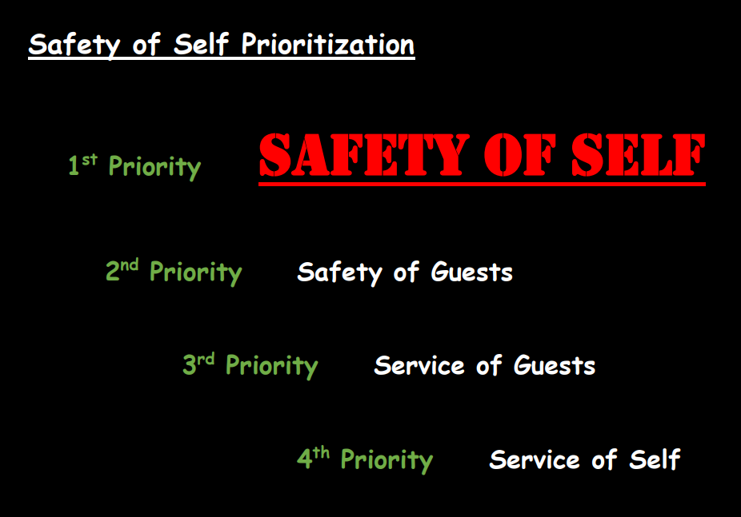

ON THE SPOT: Have you spotted a fellow employee doing an awesome job or going above and beyond? Give them a SHOUT-OUT by completing an “ON THE SPOT” recognition form. This can be done by ANYONE! The form can easily be found on the EpicEmployee app.

* Select the “My Location” tile
* Select the “RECOGNITION” drop down
* Select “WHAT IS THE ON-THE-SPOT RECOGNITION” option.
* Select the “nominate them here” option.

For quick access <https://vailresorts.service-now.com/hrportal?id=create_case&sys_id=61bc1ae987df3810d227fcc6cebb3584>

A NOTE FROM THE TRAINING DEPARTMENT:

A few years back, PSIA-AASI put forth the Learning Connection framework as a part of the student-centered focus. This framework highlights the fact that a great learning experience for the student is dependent on the instructor’s ability to blend, People Skills, Teaching Skills and Technical Skills.

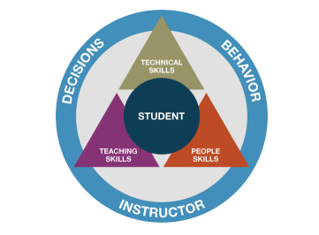As we head into the holidays there is a specific set of skills that I want to everyone to focus on, and those are People Skill. A lot of folks think that having great people skills is all about having a great personality, and even though that may contribute, it is not the only skill.

PSIA-AASI introduced the People Skills Fundamentals to the world at Interski in 2019, then polished, buffed and refined them for the latest Interski in 2023. Here is my challenge to you. Read the fundamentals and the questions I pose below. Then, as you proceed over the next couple of weeks, reflect on the lessons you taught and answer those questions.

**PEOPLE SKILLS FUNDAMENTALS:**

1. **Develop relationships based on trust.**

* How did you earn your students trust?

1. **Engage in meaningful, two-way communication.**

* How did you connect with your guest?

1. **Identify, understand, and manage your emotions and actions.**

* How did you manage the highs and lows of each lesson?

1. **Recognize and influence the behaviors, motivations, and emotions of others.**

* How did you help your student navigate their lesson?

If you are interested in further information about People Skills you can read the following article posted in the Spring 2022 Edition of 32 Degrees.

<https://thesnowpros.org/2022/05/26/how-people-skills-make-you-a-better-instructor-and-person/>

SKI & RIDE SCHOOL WEBSITE: Our Ski & Ride School website has a lot of useful information for instructors. If you haven’t already, please take a few minutes to check it out. It is always being updated, so take a look from time to time to see what’s new! [www.heavenlysrs.com](http://www.heavenlysrs.com)

STAY HEALTHY: Take advantage of another opportunity to continue your healthy lifestyle. Did you know research shows that people who regularly exercise have better mental health and emotional wellbeing? Exercise increases your overall health and increases the production of our brain’s feel-good neurotransmitters, called “endorphins”.

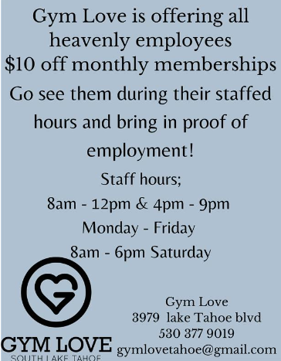

JOIN THE FUN: Get out this winter by joining the Gardnerville Bowling Series the last Thursday of the month thru March at Wink’s Silver Strike Lanes. Meet some new people and have some fun while you’re there!

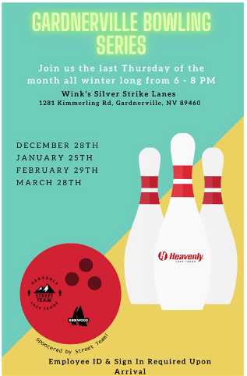

Thank you for reading and as always, THINK SNOW!