WINTER IS IN THE AIR…

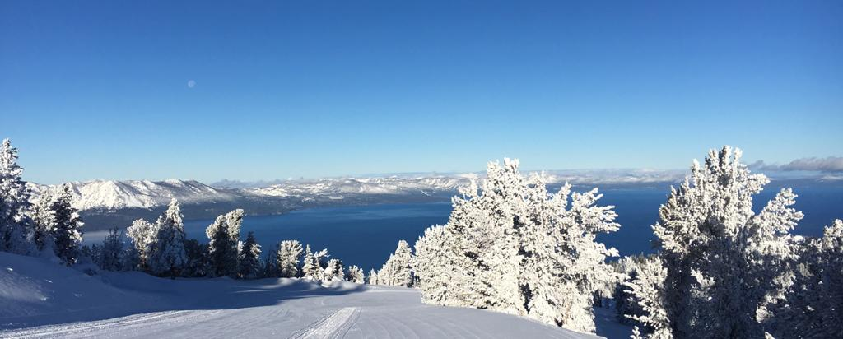

Note from Robin Barnes, Director of Skier Services:

I want to share that James Kayser will be acting as overall Senior Manager of Ski and Ride School this season, overseeing both Kids and Adults/Private Lessons.  I feel that these additional responsibilities will be natural for James with his experience and passion in all aspects of our school.  Thank you, James!

Operational update:

We are experiencing a slow start to the season and terrain is limited.

Snowmaking has been running for the past 24 hours non-stop, and we are making snow at every opportunity with the goal of opening up new terrain as soon as possible.

We are planning to open the Gondola Ski and Ride School on Friday, December 15th (wind permitting). We will also look at expanding offerings beyond 1st, 2nd timers and green level skiers and riders as soon as we have an increase in available blue terrain.

Please check your schedule daily for changes. Your manager/supervisor will be contacting you soon about schedules for the holiday period.

It’s probably best to avoid skiing/riding on the weekends until we get more terrain opened, however mid-week is relatively quiet. The weather forecast is mostly clear for the next few days, classic Tahoe skiing/riding with sunshine and warm temperatures. Please get out there and go skiing and riding. As always, be aware of everything going on around you and stay safe.

PARKING:

Employee vehicles need to be registered to park in the California Base employee lot before Dec 16 when the reservations parking will begin.  You can register 2 vehicles (although only one may be parked at any one time). Please use the link to register your vehicle. <https://app.smartsheet.com/b/form/b6589d9c9d2b482f8b228d6469d3fc5c>

BOOT CHAINS:If you are a Ski and Ride School employee in need of boot chains, please see Michelle in the Ski and Ride School Admin. office. These are free of charge and are expected to be returned at the end of the season.

WORK FORCE MANAGEMENT:

If you are interested in picking up extra shifts this season through Heavenly’s Work Force Management program, Snow Tubing is offering training from Dec 11-14.  Participants must attend all 4 days of training.  Please reach out firstly to your supervisor so they know your plans and then to Richie Monroe at [Ramonroe@vailresorts.com](mailto:Ramonroe@vailresorts.com).  Richie is the manager of tubing.

LIFT Training:

If you have LIFT training to do, please do it as soon as a possible.

Check what training is outstanding on EpicEmployee > Training, Development & Recognition > Access learning opportunities on the LIFT > The LIFT. Click on “ME” in the top right-hand corner and then on “PLAN”. You will have a list of all the trainings to be completed.

When completing LIFT training please PUNCH IN and OUT for the time you are training to ensure you get paid. Also, send an email to your supervisor so they know that you punched in and out for training on purpose and can approve your pay.

Safety:

How are you keeping yourself safe every day?  Please pay attention when you walk to and from the parking lot, as there are often slippery surfaces.  Check out this video for tips for walking on ice.  [Image Relay - welcome |](https://vailresorts.imagerelay.com/share/c38697510f8f415d99817ed390b536df)

Under normal circumstances, we should be using the walking path from the lower parking lot to the upper parking lot. Generally, we should not be walking up the road as it is not as well cleared and there is traffic using it.

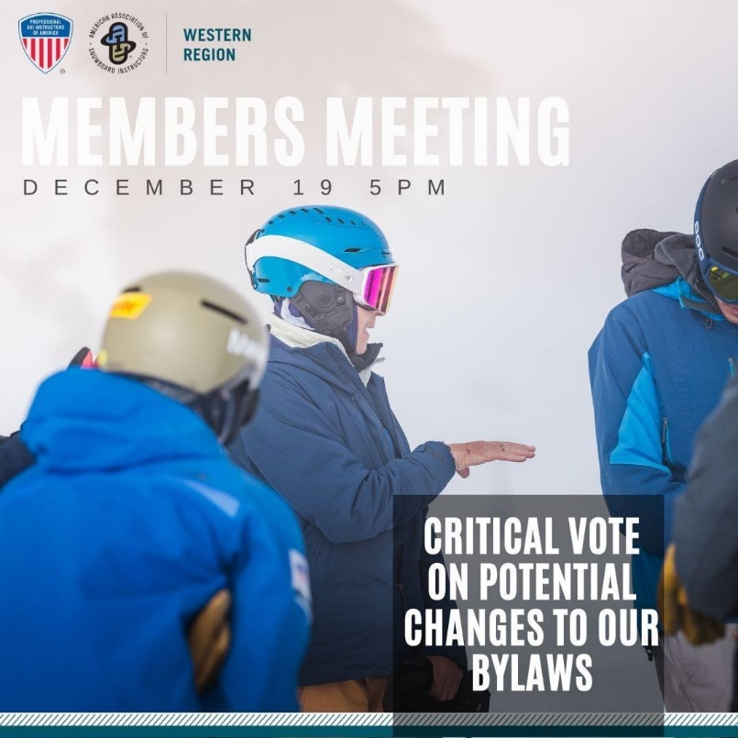

MEMBERS MEETING:You may have heard Patrick talk about an important member meeting happing in PSIA-W on December 19th. There are a number of bylaw changes that have been proposed and are going to be voted on in this meeting. Heavenly is one of the biggest schools in the region and can have a real impact on how our organization is run. Please, let’s make our voices heard.

You can read about the proposed changes here:

[Members Meeting: Bylaw Vote | 12.19.23 – PSIA-AASI (psia-w.org)](https://psia-w.org/members-meeting-bylaw-vote-12-19-23/)

**Register by Tuesday December 12th here:**

[Event Calendar and Registration – PSIA-AASI (psia-w.org)](https://psia-w.org/home/events/event-calendar/?cal-month=-12&cal-year=2023&event=9063#psia-calendar)

We hope to see you there!

Thank you for reading this and THINK SNOW!