Ski & Ride School News

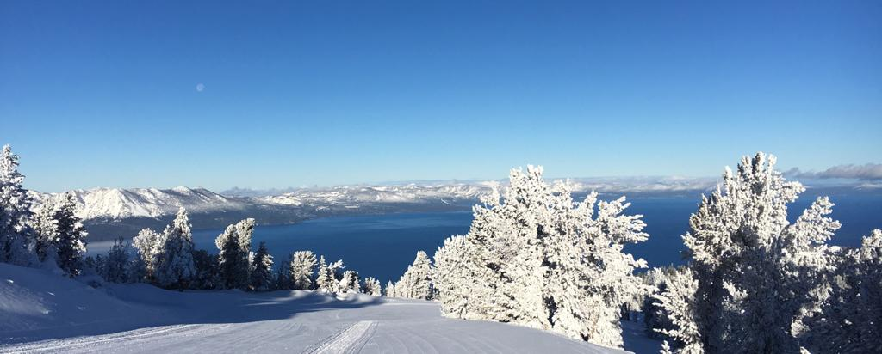

SRS Operations; a note from James:

**Ski and Ride School and the second half of the Season**

The half way point for the season was a week ago. We are going into the second half of the winter with a lot more snow and more guests!

It has been snowing and conditions are much better than they have been so far this winter with just about everything open. The forecast has things warming up a little through the middle of the month with some more snow at the end of next week.

Presidents week starts the weekend of Saturday, 2/17/24 (next weekend) and lasts for approximately 1 week. We are seeing high levels of reservations for private lessons and kids group lessons especially on Monday, Tuesday and Wednesday and are looking for as much help as we can get on those days.

It gets a wee bit quieter the week after and then we see another increase in numbers for the week of March 9th and then the week of March 23rd. The quieter times will not be as quiet as they have been the first half of the season.

Please keep an eye out for communication from your leadership team asking for help on the busy days.

If you are not working, go and ski and ride, it is really good at the moment.

Training; a note from Patrick: Throughout this season, you have probably heard the following phrases at one time or another: Safety of Self prioritization and focus on learning vs. teaching. What do these mean?

"Safety of Self prioritization" means that we, the SRS Leadership, value your safety above all else and expect you to make your safety a number one priority. Decision-making is the key to positive outcomes regarding your safety. We have the STOP Model and the 5 T’s to help us make decisions, but we need to set ourselves up from the beginning to make those good decisions. Numerous studies have shown that there are two areas that drastically affect the way we make decisions: How much and the quality of sleep we get and whether or not we are properly fueled (have we eaten). The lack of one or the other, or both, clouds the brain and impedes the decision-making process. So, from me to you, to make your safety a priority, prioritize quality sleep by aiming for 7 to 8 hours per night, and prioritize keeping yourself fueled throughout the day.

My favorite quote around the subject of learning vs. teaching is: “You haven’t taught until they have learned.” To ensure that our students' learning takes priority, we have to turn our focus away from us and onto the student. We do that by creating a learning environment that encourages exploration, experimentation, and actively engages the learner. All of this can be achieved by simply getting your class to move. Movement allows our students to explore both the terrain they are on and the skills we are trying to teach. Movement allows our students to experiment with what is going to work for them and how they can achieve success. Movement connects the student to the learning environment, and with exploration and experimentation creates engagement. Movement also opens up a world of opportunities for you to help facilitate learning by connecting with each individual in your class. Get out there, get moving, and watch the learning happen!

Upcoming Events





|  |
| --- |
| Guest Comments; As always, we appreciate the hard work and dedication of **all our staff**. We want to recognize those individuals that gave our guests an “EXPERIENCE OF A LIFETIME”.  **John D'Aintree**, **Lauren Hasse**, **Danny Featherstone**, **Devon** and **Ryan** make the experience fun. Hats off to having such a positive staff!  My ski instructors were wonderful. **Jon Sween** & **Greg Roehl**! I really appreciated them!  I really enjoyed the two beginner half lessons that I took. **Tim Rankins** has been a wonderful ski instructor. He encouraged us to try new things and helped us overcome our fears. The view is stunning, and the place and the people were very welcoming.  Our instructor **Steve** was great!  My ski instructor was phenomenal, her name was **Flo**. She kept us all entertained and she was able to explain things for the entire group to learn. Would highly recommend to family/friends if they need lessons and will be returning this season.  I took a ski lesson on 1/26, and our instructor **Charlie** was amazing! He was so patient, informative, and sincere. I would definitely recommend him to friends/family.  Excellent ski school. **Walter Egan**. **Steve Scott**. **Kevin Killeen**.  I took a beginner lesson and the instructor **Alex** was really encouraging and helpful.  Our instructor **Josefina**, was absolutely the best! Very welcoming, very patient and extremely knowledgeable. She explained best practices, safety and how to have fun while skiing. She made our experience unforgettable and so much better!  I would like to recognize **Bill Mellerup** for his great guidance when I took my lessons. He made me feel very comfortable! |

Thank you for reading and as always, **THINK SNOW**!

**Ski & Ride School Administration**

Robin Barnes, Director of Skier Services

James Kayser, Sr Manager, Children’s Ski & Ride School

Patrick Harrington, Training Manager, Ski & Ride School

Amy Rice, Administrative Manager, Skier Services

Taylor Garland, Hiring & Payroll Coordinator, Ski & Ride School

Michelle Ashton, Administrative Assistant, Ski & Ride School

[snowschool@vailresorts.com](mailto:snowschool@vailresorts.com)

heavenlysrs.com

530-542-5131