Ski & Ride School News

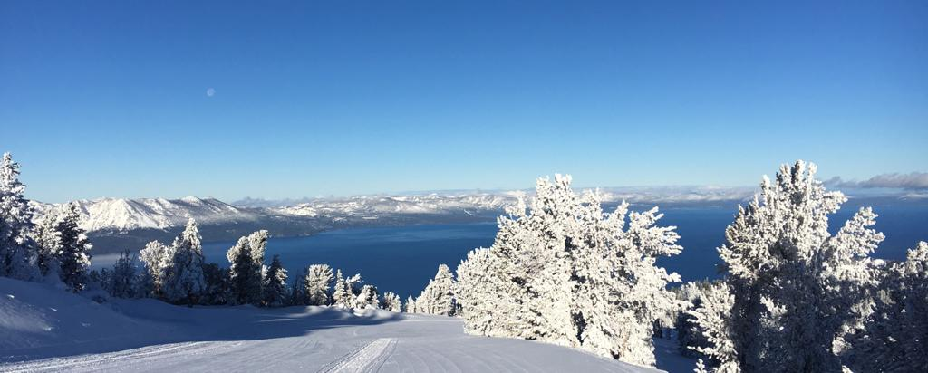

Hi Team!

We are about halfway through the season already and so far it has been a fairly dry year! Nothing compared to this time last year! Good news though, according to the National Weather Service, a pattern shift should occur Wednesday into next weekend, as a winter storm is expected to bring heavy high-elevation snowfall! Keep your fingers crossed!

Last week, we celebrated Brian Ludlow and his 39 seasons of leading CA Kids! It was a touching event and many past and present employees and friends were in attendance. Thank you to those who were able to attend! If you took any photos, please send them to [snowschool@vailresorts.com](mailto:snowschool@vailresorts.com) and we will get them to Brian.

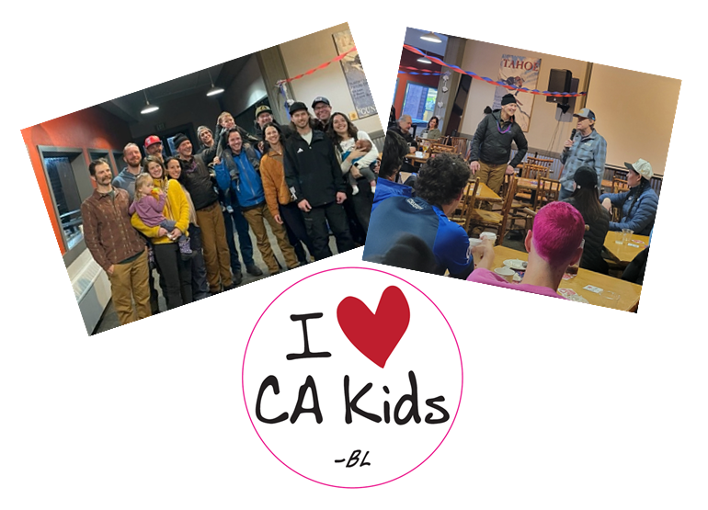

**KIDS SRS LEADERSHIP UPDATE**

With Brian Ludlow retiring, the Kid’s leadership team has been rearranged slightly. Ingrid Heinig has kindly agreed to step in and lead the team until the Manager job is posted and filled. Jamie Crueger, Tiffany Grimes and Matt Morse will continue in their current positions at CA Kids. Matt has recently returned from his injury in the fall and will be here for the second half of the season. Dave Burkett will remain at Gondola Kids with continued support from Kyle Jarratt, Darren Marshall, and Yaya Meza. We will let everyone know once the California Kid’s Manager Position has been posted.

**PRO CONNECT TOOLS UPDATE**

There have been a couple of updates to Pro Connect Tools over the past week.

**Meal and Rest Break Attestations**

The meal and rest break attestations are now part of the Pro Connect Tools App.  At the end of your work day you need to click on the *Final Attestation* button.

The two questions are the same and are required to be answered daily, not matter the length of your shift.

1. Were you provided the opportunity to take meal periods per the policy?

2. Were you authorized and permitted to take rest periods per the policy?

The answer in both cases will be a simply Yes or No.

More information on the California break policies can be found HERE: [Team Member Handbook - CA and NV Addendum](https://vailresorts.policytech.com/dotNet/documents/?docid=1318)

**Failed Punch-Out Notification**

If for any reason your punch out does not go through at the end of the day the system will notify you. You can either try and punch out again or inform your supervisor that the punch out failed and we will enter it manually.

If you are using your phone for punching in/out, you may need to clear your cache for the updates to register. For question on how to do this please ask your supervisor or SRS Admin.

**TRAINING UPDATE FROM PATRICK**

Before Christmas, I wrote a bit about the People Skills Fundamentals, and then proposed a challenge. Reflect on your lessons taught and see how you integrated these skills into your lessons. Now that we have had some time to teach, and hopefully reflect, I want to dig into one specific skill, and that is building trust.

Building trust is important for a multitude of reasons. It increases the guest’s sense of safety, gives the guest confidence in moving out of their comfort zone and creates a positive learning environment. In a nut shell, trust is the key to allow for learning to happen.

What are some ways that we can gain the trust of our students? Well, we get a little inherent trust just by putting on the uniform and being in front the class, but honestly, that trust can be fleeting. To reinforce that already given trust, we have to be authentic. The best and arguably the easiest way to show our authenticity is through sharing our passion for sliding on snow. Let them know why you love sliding, why you love teaching, be excited for the learning that is happening. Passion is contagious; it brings energy and excitement to the learning environment, and shows that we really care about what we do.

So, to gain that trust, be authentic and lean on your passion for this sport. When you do that, you will be surprised at how effortlessly you connect with your students.

**GUEST COMMENTS**

We have had **JD Peterson** for our kid’s last two private lessons at Northstar.  We booked another lesson for Monday February 19th (again at Northstar) and we would like to make sure that we get JD again. We have done a number of lessons in the past as well as ski schools and have found that a large amount of time can go into discovery of the kid’s needs and current level.  JD was great and it would be extremely helpful to us if we could maintain a few more lessons with him.

My snowboard instructor, **Mark Ortiz**, was absolutely amazing! He was knowledgeable and tried many different approaches to improve my riding. But most importantly, Mark put safety first above everything else. Safety is No. 1, and I could easily identify his decisions were always based in that value.

**Giovanni G.** was the group instructor when I went on 1/20/24 and he was attentive to each member of the group's needs and really worked on helping us get better. He gave very clear and visual instructions/tips on snowboarding technique which really helped. The snowboard/ski school staff was also very caring and patient with my son that day as well. I love that they feed them lunch included with the price of the lessons! I didn't get the girls names but they worked on 1/20/24 and one of them was from Michigan.

My ski instructor for the day, **Jon Sween**, was incredible! He had an eagle eye for the areas in which I needed to improve and clearly explained and demonstrated concepts making it easy to learn. Jon also made sure everyone received individual attention and kept us laughing throughout the session. Thank you, Jon, for a fantastic experience!

Excellent experience, friendly people, outstanding service, wonderful views and scenery, California lodge runs (especially Maggie's) among the very best. A special note to **Josefina**, my ski instructor for her dedication, patience and expertise.

This was my first time skiing EVER! **Terrence Coupe** was my coach. I couldn't ask for a better experience. His instruction and cues are so well executed. He is energetic, encouraging, professional, and focused. He really wants you to get it! I went from being a first-time skier to riding down blues squares at Heavenly and Kirkwood... by day 3!!!- Please let him know!! Next time I return for a lesson, I will DEFINITELY request Terry. Thank you!!! <3 <3 <3

I was very appreciative of the lesson organizers as I registered for the first time class since I hadn’t skied for 10 years, and they helped bump me to the correct group so I could refresh my skills and also learn new techniques. I appreciated that they watched the group to see if anyone needed to be adjusted to different group so they could maximize their experience. **Tim** also gave a fabulous lesson!

**Victor** was excellent during our snowboard lesson. He was patient, kind, and extremely knowledgeable. Other staff there were more than happy to answer our questions and direct us to where we needed or wanted to go.

We were excited to have **Maeva** as our ski instructor.

John, my group lesson instructor, was 10/10 and my favorite ski experience of my entire trip.

**Ash** was an awesome instructor for our two young kids learning to snowboard. We keep coming back to heavenly just to get lessons with Ash.

We had a really good time with our private instructor **Greg Lyons,** and we appreciated his expertise!

I really liked my ski instructor, **Tim**.

The gondola was the best as well as the ski school and lessons. Our ski instructors were great! **Bill** and **Adam**.

**ON-THE-SPOT AWARDS**

Our On-The-Spot recognition program is a peer-to-peer program where employees can recognize each other for demonstrating values-driven behavior.

**Greg Neal** (nominated by Jasmine Reichardt) Be Safe value. Did a great job of keeping his class out of harm’s way on a very busy day/run.

**Brian Shelton** (nominated by Jasmine Reichardt) Be Safe value. Was extra aware of safety in his class handling skills on Patsy's with his LV4 kids group of 8.

**Dustin Goralski** (nominated by Sheri DeGraffenreid) Serve Others value. Dustin is always ready and willing to help with anything we need and frequently offers to help with our one-off special situations even before being asked. A good example of that was today when he offered to sit with and keep an eye on a boy from our kid's SRS who needed some extra attention. This freed up the children's center employee to be able do what she needed to be able to contact parents, etc.

**Amy Rice** (nominated by James Kayser) Serve Others value. Amy organized a bus for Ski and Ride School international employees, and others from other departments to organize their social security numbers in Reno this week.

**Want to recognize a coworker? Check out the On-The-Spot recognition program!**  [Learn more about On-The-Spot recognition here](https://vailresorts.service-now.com/hrportal?id=knowledge&sys_id=d56239f687f2b85064938596cebb351b).

**AUSTRALIAN RESORTS ARE HIRING**



**Thank you for all you do! Think snow!**