HAPPY NEW YEAR!

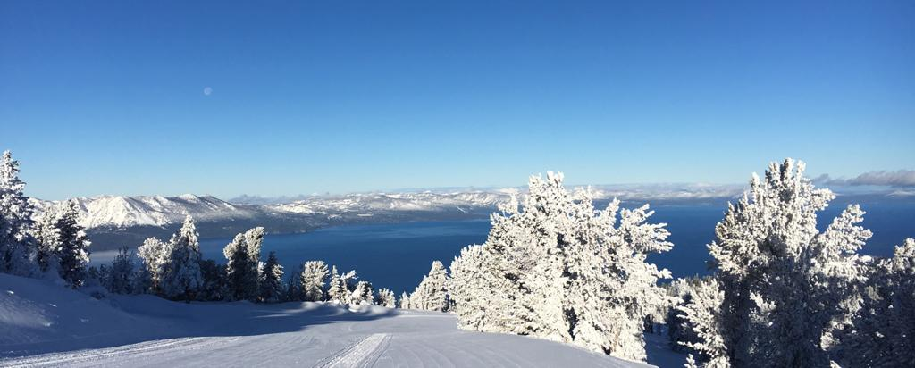

SRS Operations; a note from James:

We have had some new snow and the skiing/riding are significantly better than they have been all season. In addition, we have more snow in the forecast.

We hope that we will see a continued uptick in business as a result of the new snow.

This time of year, is often a little quieter in Ski and Ride School and as a result we will continue to focus on scheduling full timers first.

**Some ways to take advantage of the slower period**:

* This is a great time to go elsewhere and take advantage of the skiing/riding at our sister resorts. Kirkwood and Northstar are free with our passes.
* It is still busy on weekends with D-team, Comets, Epic Promise and Douglas County.
* Training is up and running for the season. Please sign up on instructor.snow.com.
* If you want to take time off during the season now is a good time. This slower period will likely only last 3 or 4 weeks.
* There may be possibilities for other work elsewhere, please talk to your location leadership.

**An ask**:

The skiing/riding are significantly better than they have been, however we still do not have massive amounts of snow. Any areas off the groomed trails are still full of obstacles.

There have been numerous incidents both here at Heavenly, across Tahoe and elsewhere in the States.

Please take care, make good decisions and stay safe. If in doubt stick to the groomed terrain.

Training; a note from Patrick: We have made it through the holiday’s and this is the time during the season where a lot of us look to some type of training. I want to share some amazing training opportunities both here at Heavenly and outside at other Vail Resorts.

**Adaptive** trainings started this week and will be running every other week throughout the remainder of the season. This is a great opportunity to view teaching skiing and riding from a whole new vantage point! Here are the dates up to President’s week.

-**Jan 17th 9am-12pm**, on snow- Cognitive Impairments

- **Jan 23rd 5pm-6pm** (Zoom), **Jan 24th 9am-12pm**, on snow - Bi-Ski

              - **Feb 6th 5pm-6pm** (Zoom), **Feb 7th 9am-12pm**, on snow-Visual Impairments

**Heavenly Trainer Series –** These 3hr clinics are open to instructors from all disciplines interested in what it takes to become a trainer. Pre-Requisite: Must have at least a Level 2 certification (PSIA-AASI or equivalent).

**January 25th 9:00am – 12:00pm & 1:00pm - 4:00pm** Topic: Clinic Leading vs Lessons.

Balancing teaching skills, people skills and technical skills to create engaging learning environments.

**February 13th** **9:00am – 12:00pm & 1:00pm – 4:00pm** Topic: Training Without Bias.

Developing outcome-oriented feedback using various models.

**February 29th** **9:00am – 12:00pm & 1:00pm – 4:00pm** Topic: Practical Application

Refine your clinic leading skills through practice, peer review and group feedback.

**Teaching Children Snowsports Online -**Every **Friday Night 5:00pm to 6:00pm** via Zoom **-** Join our engaging Zoom meeting series designed for snowsports instructors and enthusiasts eager to enhance their teaching skills using the Cognitive, Affective, and Psychomotor (CAP) model. In each session, we delve into effective strategies, engaging games, and innovative techniques tailored specifically for teaching children snowsports.

**Okemo Tech Talks** - A biweekly tech talk webinar series, from our counterparts in Okemo Vermont, directed towards ski and ride instructors featuring experts from around the Vail Resorts network. Join us every other Wednesday through the winter season at 7:00pm on Zoom.

**NEXT WEBINAR: WEDNESDAY, JAN 24TH @ 7:00PM -** “PERFORMANCE ANXIETY IN SNOWSPORTS” FEATURING: QUINN FERGUSON, M.S. SPORTS & PERFORMANCE PSYCHOLOGY

Join the webinar here: [**LAUNCH ZOOM MEETING**](https://us02web.zoom.us/j/81542015422?pwd=b3Z2RzRYVGdYb3dJSmxhS2ZMSWN5QT09)

You can find the entirety of our training schedule on <https://heavenlysrs.com/> or via our training portal on [instructor.snow.com](https://instructor.snow.com/snow/instructorTools.asp).

Vail Resorts; **a note across Vail Resorts emphasizing the importance of: Epic Wellness**: Please click the link below to view the email from our Wellness Director, Corey Levy, Psy. D. Wellness Resources for You

**Western Region Scholarships:** Please click the link below to view the email regarding available scholarships. Applications are due no later than 5pm PT on Thursday, Feb. 1, 2024. [Western Region Scholarships](https://mailchi.mp/psia-c.org/education-foundation-august-news-interski-takeaways-on-soft-skills-12454187?e=8bb1fed273)

|  |
| --- |
| Continuous Listening Employee Survey; Thank you again for taking the time to provide feedback through our Continuous Listening Survey.  We are currently looking at the results and would like to share the top 3 strengths and top 3 opportunities.  As we continue to review the survey comments we will gain a deeper understanding of where we are doing well and where we can improve.  **TOP 3 STRENGTHS**  1.       **Training:**  I am satisfied with the training I have received for my present job.  2.      **Intent to Return:**  I would consider working again for Vail Resorts if the situation were right.  3.      **Manager**: I would recommend my manager to others.  **TOP 3 OPPORTUNITIES**  1.      **Larger Purpose**:  Working for Vail Resorts gives me a sense that I am part of something with a larger purpose.  2.      **Physical Safety**:  I feel safe at my workplace  3.      **Job Preview:**  My experience so far matches the way the role was described.  Guest Comments; As always, we appreciate the hard work and dedication of **all our staff**. We want to recognize those individuals that gave our guests an “EXPERIENCE OF A LIFETIME”.  The instructor for our private lesson was amazing. His name is **Travis**.  **Savannah Lockwood** was a great ski instructor!  **Autumn** was great!  Super friendly staff and instructors.  **Kevin Killeen** and **Heidi Ettlinger** are the reason we ski at Heavenly.  I want to say thank you to the staff that made the experience special-our ski instructor especially. Our ski instructor was so kind and funny.  **Russ Snow** was a fantastic ski instructor!  We chose to come back for day 2 because my boys had a blast with **Jack** and they learned so much.  **Mark** our private lesson coach was fantastic!  **Greg Roehl** was the perfect instructor for me. It had been a number of years since I had skied, he met me where I was in terms of my experience, ability, & lack of familiarity with the new style of equipment, and helped bring me back up to speed on the moguls.  The instructors made it such a wonderful experience! **Willy Green** was especially attentive, motivating and an overall amazing instructor during my group class! I improved so much with his tips!  **Andrew Sutton** is/was a great snowboard instructor. I would love to learn from him again! Will definitely return for lessons from this gentleman!  I had an excellent time with snowboard instructors **Don** and **Hank**. Both were extremely professional and supported not only me but all the students to move forward and having fun!  I had my first and second ski classes and really appreciate the professors help all the time during the classes, both **Craig** and **Lucas**. Lucas was really helpful on my second lesson, and helped me to get more confident about skiing and teach the correct movements.  **Tom Sinclair** was THE best private ski instructor. The value of the lesson was well worth it. Tom was great in teaching skiers of different levels (there were 4 of us) and he was so friendly. Post-lesson Tom also helped critique our ski videos, which was fun. We highly recommend Tom to ANYONE.  I took an adult group lesson with **Sterling** on 12/31/23 and it was a fantastic way to end the year. His coaching was personalized and patient and always upbeat and encouraging.  Our instructor (**Ryan**) for snow board lesson was great! He was knowledgeable and a good teacher.  **Paulette Irving** was a fantastic ski instructor. Highly recommend. My daughter has a disability and Heavenly was able to provide a highly qualified instructor to teach her in a private lesson. My daughter loved her experience and wants to come back. Can't ask for a better result than this!  **Tim** was such a great instructor. I really feel comfortable skiing now, and will be returning to Heavenly. He is great at explaining things in a way that the whole class seemed to understand and translate over to their skills.  I am giving these all 10's to be directed towards our instructor **DANNY** who was fantastic!!! He took great care of us and we can't wait to come back to the mountain to continue learning from him. He is a 10 across the board and you guys are lucky to have him as an instructor!!  My 9yo old son and I both took two lessons to improve our riding. My son had **Josh Fowler**; he looked so much better even after the first lesson as they worked on smoothing out his technique. I had **Nina Gandhi** and **Ethan** (last name?) for my two lessons and both were awesome! I feel more confident in my abilities after my time with them. My son also made friends with a few lifties (Justin at Canyon/Sky Express and another at Patsys he rode the chair with) and those interactions really were the icing on the cake. We love Heavenly and are looking forward to returning next season. The mountain is awesome, but the staff make it even better. Thank you for all your hard work!  Our instructor was EXCELLENT (**Meagan Collins**)!!!! She was welcoming, happy and knew how to handle the kids 3 &7 being a stranger to them.  Our snowboard instructor, **Evan**, was fantastic!  I did a private lesson, with my sons, with **Lisa Matthews** on the mountain by the Tamarack Lodge. Lisa Matthews is great! We were very impressed by her and she is great with kids! I cannot positively praise Lisa Matthews enough, she is awesome!  Lessons with **Tim Rankins** were amazing!  **Sawyer** who was my daughter’s ski school instructor really helped her to progress as a skier.  **Sony** was an amazing instructor!  **Austin** from the ski school was our private instructor. He made the day for my 7-year-old. He is an excellent teacher, and hope to see him again soon.  **Nicolas Gardiner** was a great instructor for first time snowboarders. We will be back for more lessons.  Ski instructor **Troy** was so great for my timid adult kids. He was kind and understanding and made sure we all had a good lesson!  **Willy** at California lodge ski school was the BEST teacher. He was honest about our abilities and offered recommendation for us when we should go up and tackle the larger runs. He was right!  **Tad** was a great instructor!  Child Snowboard Instructor **Nick H** was excellent!  My snowboard instructor **Luba** was amazing! She went above and beyond to ensure I grasped the fundamentals of snowboarding and gave me space to learn at my own pace. By day 3 I was making S turns on a green run! She is very encouraging and allows her students to learn at their own pace and gives tons of positive feedback.  My daughter had group lessons with **Charlie** Dec 17th. He was amazing. She had 2 more classes and they were both with Charlie on the 20th and 21st. He is very engaging with the kids. He is super knowledgeable about the progression of snowboarding which is very helpful to parents to continue working with their kids. Charlie is by far one of the best and most engaging kid instructors that our children have had. He builds the kids up and helps give them the confidence they need while making learning fun. |

Thank you for reading and as always, **THINK SNOW**!