Ski & Ride School News

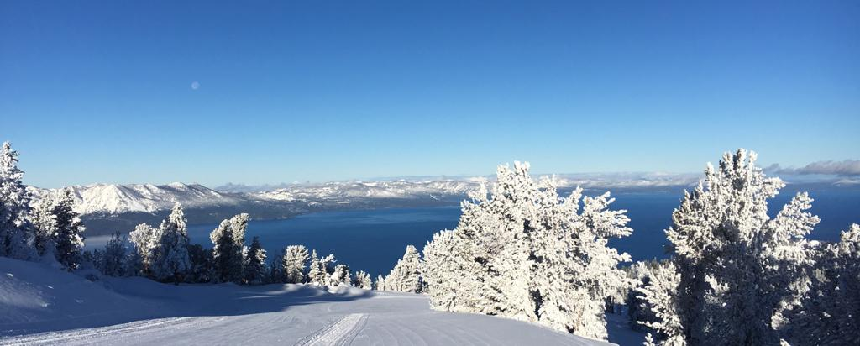

Did someone say “Miracle March”?! Let’s gear up for some late season snow! Please remember to keep yourselves safe during what is expected to be a gnarly storm heading our way!

|  |
| --- |
| cid:image002.png@01DA6A5E.528B9380  cid:image004.png@01DA6A5E.528B9380  cid:image011.png@01DA6A5E.528B9380  Continuous Listening Survey; Your voice matters: Please take a moment to complete the Continuous Listening Survey. The Continuous Listening Survey is a valuable opportunity for you to have your voice heard by providing open, honest, and confidential feedback about your experience working for Heavenly and Vail Resorts.  Please scan the QR Code below to complete this anonymous survey by **March 1**    Congratulations To Our Newly Certified Instructors; We would like to take a moment to **ACKNOWLEDGE** and **CONGRATULATE** the following employees for successfully obtaining their **LEVEL 1 CERTIFICATION!**  William Alderman - Ski  Scout Beaupré - Ski  Delfina Castillo - Ski  Lisa Dossey - Ski  Maria Fritzsche - Ski  Kylie Gerkin - Ski  Alexander Koester - Ski  Mari Kool - Ski  Evan Nixon - Ski  Greg Salazar - Ski  Alexandra Wagner - Ski  Susie White – Ski  Belinda Yan - Ski  Blas Ibanez – Ski & Snowboard  Gavin Fylstra - Snowboard  Choi Kwun McGannon - Snowboard  Alexandra Moretsky - Snowboard  Sony Graeb - Snowboard  Guest Comments;  The mountain is great and our private lesson with **Danny Featherstone** was great as always.  **Ivana Burkett** is an excellent instructor  My wife’s private instructor, **Mike McClary**, was patient and extremely helpful  My daughter was in beginner snowboard ski school and **Jason** really helped boost her confidence in the lesson and upon observation on the slopes the following day. Bailey also provided a great final lesson of the week.  Ski Instructor **Suzie** was fantastic!  The reason why we will return to Heavenly is because of our private lesson instructor **Autumn**. She is so great to work with and we are definitely coming back to have more lessons with her. She was the highlight of our visit.  The staff at Heavenly are amazing - especially ski school! They made access and changes to lessons and days easy on us! Instructors (**Julian** and **Frank**) were awesome! Responsive and wonderful team! Thank you all you’re the reason our vacation was smooth, rewarding and easy!  My instructor **Choi** was great. I learned a lot from her. Will be returning very soon.  **Joe** my instructor was cool guy and very knowledgeable. Helped me get off the ground.  Lisa was a great ski instructor. During ski school **Lisa** exceeded expectations. She was focused on safety and was always scanning uphill and downhill. She noticed two kids wandering alone and took quick action. Also, one student felt light headed during class and she assisted. Lisa is the best.  **Russ Snow** was my trainer. He helped me feel confident and secure, I felt strong and positive about my experience. He rooted me on, kept things light, and had good energy. He guided me on slopes which I would have never done alone. I am so happy to have had this experience and want to have Russ again.  Our group took a private lesson with **Victoria** (snowboarding). She was an excellent mountain guide and instructor!  The mountain was amazing. We had the best time. Although we were there on a holiday weekend, the chairlift lines were not very long. The staff was so friendly and helpful. Our 2-year-old son took a lesson with **Terry**, and he was an incredible instructor! Would 10/10 recommend taking a lesson with him!  **Bob Haas** is an absolutely amazing instructor!  Overall fantastic experience for our first family ski trip. Our private lesson coach, **Katarina Fenton**, was amazing! She was able to help our entire family who are all new skiers, ranging from age 4 to adult, feel comfortable skiing after 2 lessons with her.  My snowboarding instructor **Hank** was amazing and so helpful. Even though it was a group class he took the time to assist everyone and ensure they were comfortable with the skills that he was teaching. Because of Hank I bought a second day lift ticket and did my first ever run!  **Tim F** was a fantastic instructor! He gave me the perfect instruction to unlock my skiing technique. I had the best trip thanks to Tim F.  The lessons we took with **Autumn** and **Lisa** were fantastic and made us feel confident in our ability to ski. 100/100 recommend!  Ski instructor **Ellen** was great!  **Lucas** was great. We took a private lesson for our family and he did a fantastic job. He was patient with my children and the entire family. Really enjoyable experience for our family.  I had **Ivana Burkett** in my 2nd day of learning and I really appreciate her as a trainer.  Everyone was so nice and helpful! **Peter G**. was my ski instructor and he was extremely helpful, funny and made sure we all had a great time!  Amazing first lesson. **Steve Scott** really made my experience. He was a wonderful instructor and helped the group not only navigate new techniques, but made it fun. I can honestly say I am significantly more confident and excited about skiing because of him!  **Ryan** was very helpful and a great instructor for my family.  **Kevin K** on the instructor team is amazing.  My ski lesson instructor **Jamie** at the California lodge made my experience 100% worth it. I hope he keeps teaching because I was able to improve my skills significantly through his teachings.  **McKenna** in the snowboarding school was great - she was with our son for two days and really helped him.  **Nathaniel S**. was my instructor for snowboarding lessons and he was very friendly, knowledgeable and patient.  I had a FANTASTIC lesson with **Evan Nixon**. During our group lesson he was friendly, extremely knowledgeable, and supportive. He even led the group in song when we shared that this was a 40th birthday celebration for my husband. Evan made something daunting, fun. He praised and gently corrected us through the falls and I believe everyone in our group felt successful. I'm extremely grateful that he was our instructor. He laid a solid foundation for us all to build upon in the future.  My ski instructor was **Tim** and he was fantastic! He pointed out to me why I was getting off balance and falling.  My instructor **Tim Fajen** was great and he even went over our time and it did help build my confidence and skills!  Our instructor **Tad Dodson** was fantastic!  **Scott Schroder** was an excellent ski instructor 10/10 & all staff were friendly & helpful.  **Tad Dodson** is an extremely warm, personable instructor. I had the best lesson I’ve ever had with him.  **Terry** was good ski instructor  Our ski coach **Matt** is very knowledgeable and has 20+ years of experience, he helped us learning braking and turning on the first day.  Our snowboard coach **Mike** is very kind and also very knowledgeable. He gave personalized instructions based on each person's condition, and basically provided private lesson for each of us. I learned how to brake and to turn on the very first day.  Great learning experience for Granddaughter (5 years old) in ski school. (instructor **Lia**). Friendly staff.  Great lessons by **Derrick** and **Ivana Burkett** through the ski school.  Our Ski Instructor **Steve Fullard** was great.  Ski instructor **Richard** (the Aussie) was phenomenal - showed us how to navigate the mountain, all the best runs, great instruction (particularly on moguls & form)  **Charlie** was a wonderful instructor!  I had an absolutely amazing two days of private snowboard lessons with **Danny Featherstone**. He got me back up to speed after 6 years away, to confidently running a ton of blues in my second day. We even made it into the park, where I had been before but not with such strong instruction, I really felt like I belonged.  I will definitely come back to Heavenly and request more lessons with **Danny**, as well as refer him to some friends that are also looking to level up their skills!  We had our first company offsite to Tahoe last weekend and **Sarah Bens** was our snowboard instructor. I've taken many private lessons before at various different resorts, and I can say, unequivocally, that Sarah was the best instructor that I've ever had. She's a fantastic teacher, listener, and has an unparalleled ability to help snowboarders level up. What truly sets Sarah apart is her genuine commitment to her students' progression. She listens intently, tailors her feedback to individual needs, and champions every small victory, fostering an atmosphere of trust and encouragement. Under her guidance, I witnessed not only my own skills dramatically improve but also those of my employees, each of us at different levels of proficiency. I felt compelled to share my experience directly with you to ensure that Sarah's exceptional contributions are recognized and celebrated. Thank you for fostering an environment where instructors of Sarah's caliber can thrive.  As always, we appreciate the hard work and dedication of **all our staff**. We want to recognize those individuals that gave our guests an “EXPERIENCE OF A LIFETIME”.  Upcoming Events; We have several exciting events coming up!! If you’re planning to attend the International Farewell Party, please be sure to scan the QR to receive your digital ticket. You will need this as well as be an active employee to attend. We hope to see you there! |

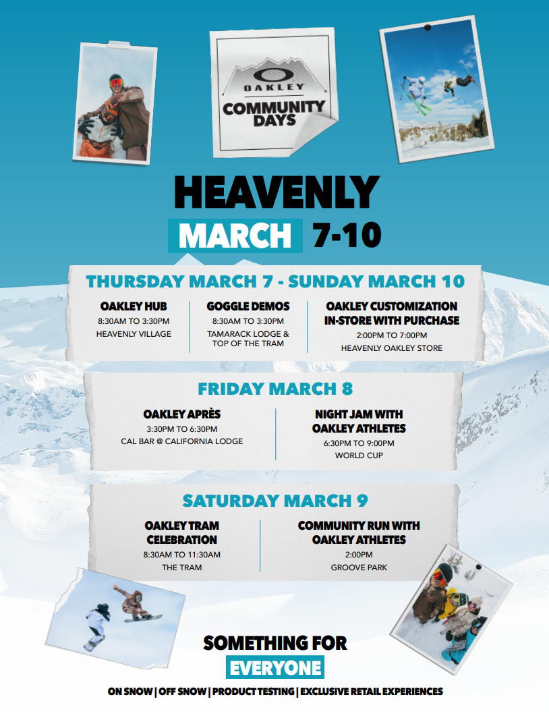

Thank you for reading and as always, **THINK SNOW**!

**Ski & Ride School Administration**

Robin Barnes, Director of Skier Services

James Kayser, Sr Manager, Children’s Ski & Ride School

Patrick Harrington, Training Manager, Ski & Ride School

Amy Rice, Administrative Manager, Skier Services

Taylor Garland, Hiring & Payroll Coordinator, Ski & Ride School

Michelle Ashton, Administrative Assistant, Ski & Ride School

[snowschool@vailresorts.com](mailto:snowschool@vailresorts.com)

heavenlysrs.com

530-542-5131